**General Information**

BSE-Aggregator is desktop extension to BSE-A4VM mobile app to aid veterinarians to combine the collected data (CSV files) from BSE-A4VM in to a single CSV file. It can export a single file from any number of files and find ambiguities in the data as well, the mass export of data in CSV format that can be used with MS Excel or other data processing applications.

### Download the app from:

<https://github.com/santoslab/apps-4-vet-med/releases/download/1.0/Aggregator.jar>

### Startup screen:

There is only one Screen on this aggregator app.

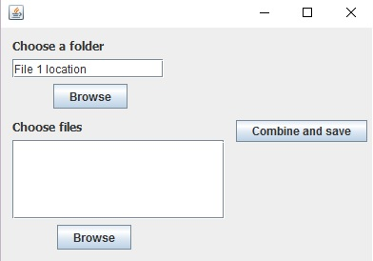

The app gives you 2 options from which you can choose from

1. Choose a folder
2. Choose files

And then an option to combine and save the file.

### How to generate an aggregated CSV file with 2 or more CSV files:

Step 1) Click the button “Browse” under Choose files

Follow the screen to the folder where your csv files are located.

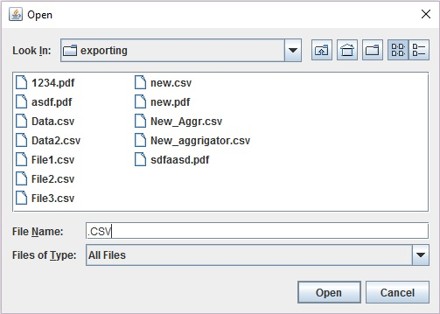

Step 2) press ctrl and Select all the CSV files that are to be aggregated.

Step 3) Click the “Combine and Save” button and save the file with (Some-Name).CSV (it is recommended to have a (.csv) at the end of the file name else you will have to choose a program to open the file.)

### How to generate an aggregated CSV file with a folder containing CSV files:

Step 1) Click the button “Browse” under Choose folder

Follow the screen to the folder where your csv files are saved.

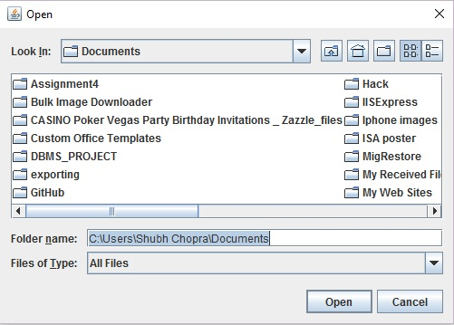

Step 2) Select the desired folder.

NOTE: The desired folder must contain only CSV files else the app wont be able to aggregate the file.

Step 3) Click the “Combine and Save” button and save the file with (Some-Name).CSV (it is recommended to have a (.csv) at the end of the file name else you will have to choose a program to open the file.)